**CHAPTER 6**

**SIMULATION RESULTS AND DISCUSSIONS**

**6.1 RESULTS OF THE FINAL ALGORITHM**

A hundred UEs are positioned in a pseudo random manner at a time instant t1 as shown in Figure 6.1. After dt seconds, the positions of the UEs are arbitrarily changed by assigning random velocity to each UE for two other time instances t2 (t1+dt) and t3 (t1+2 x dt).

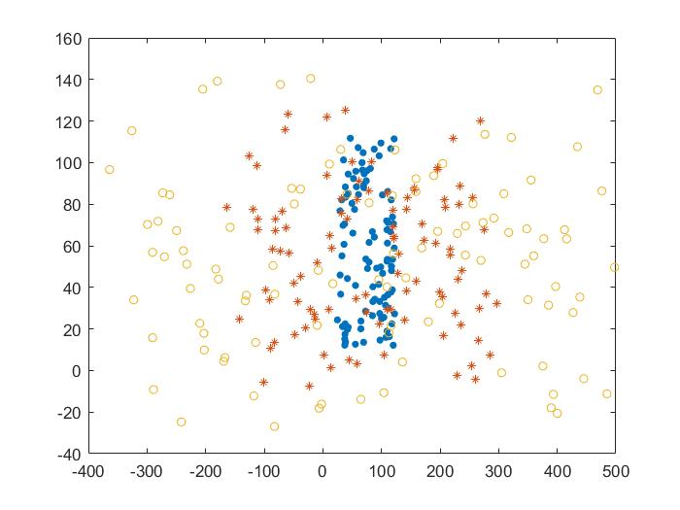

Figure 6.1 Position of 100 UE’s at time t1, t2 and t3

The cluster size is obtained using mean shift clustering and the clustering is done using K-means clustering. From each cluster, the algorithm selects an UE to act as a VBS using power received, battery discharge rate and SINR, at time instance t1 as shown in the Figure 6.2.

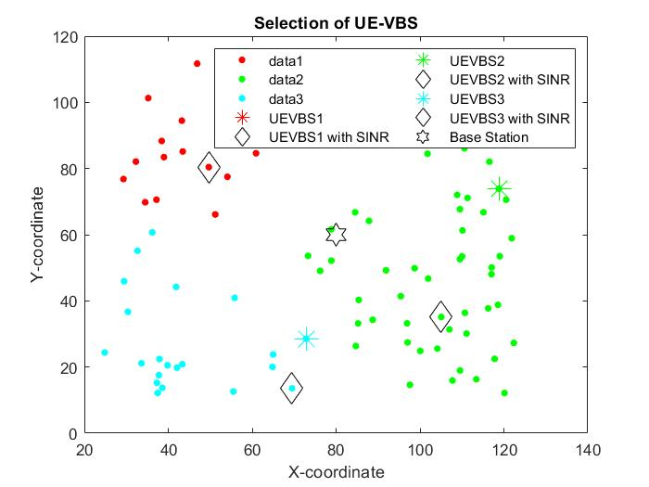

Figure 6.2 Selection of UE VBS for 100 UEs, at time t1

The power consumption in each cluster is computed using the difference between transmitted and received powers between the UEs, Base Station and UE-VBS, selected at using the algorithm, at time instance t1, as shown in the Figure 6.3.

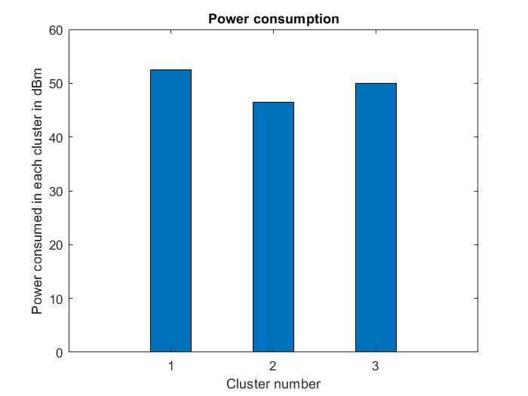

Figure 6.3 Power Consumption at time t1 for 100 UEs

From Figure 6.4, it is observed that QoS values are close to 1 in each cluster at time instance t1. Thus, it can be inferred that all the UEs receive a good quality 5G connection. Hence, applications like streaming, video calls and gaming experiences will match the satisfactory levels.

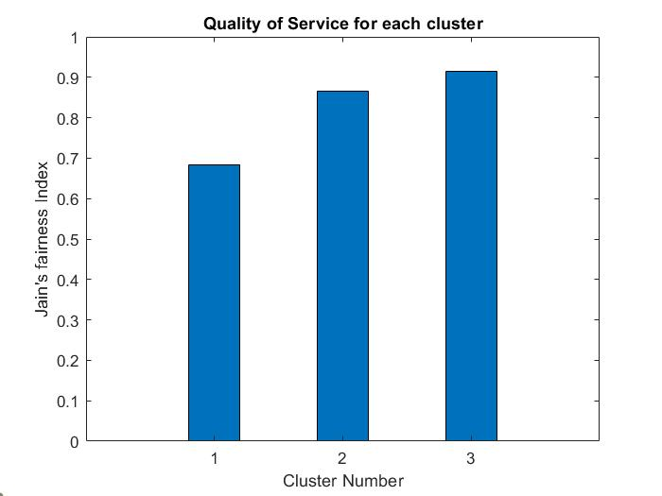

Figure 6.4 Quality of Service at time t1 for 100 UEs

The average sum rate for each cluster is computed using the Shannon-Hartley theorem for an UE VBS selected by the proposed algorithm against an UE VBS selected at random (and for an LTE base station) at time instance t1, as shown in the Figure 6.5.

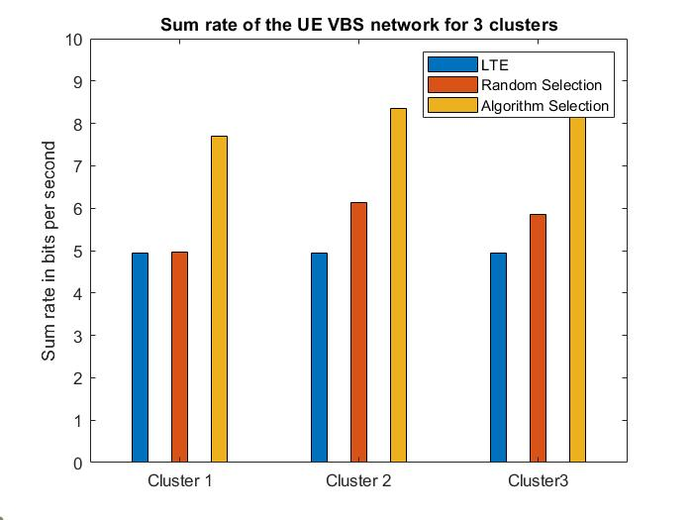

Figure 6.5 Average Sum rate for different clusters at time t1 for 100 UEs

From each cluster, the algorithm selects an UE to act as a VBS using power received, battery discharge rate and SINR, at time instance t2 as shown in the Figure 6.6.

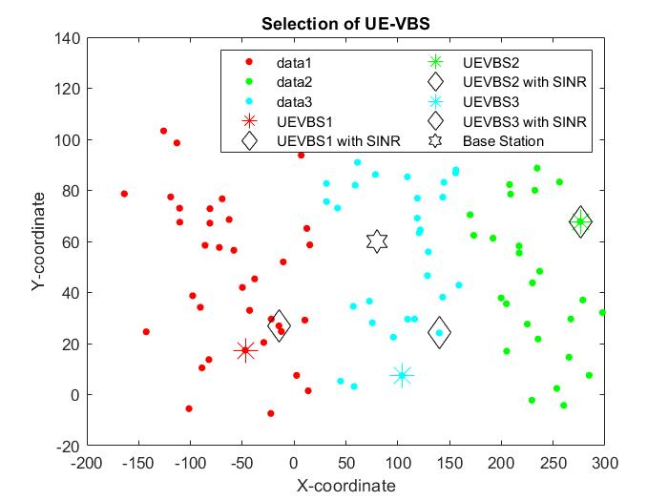

Figure 6.6 Selection of UE VBS for 100 UEs, at time t2

The power consumption in each cluster is computed using the difference between transmitted and received powers between the UEs, Base Station and UE-VBS, selected at using the algorithm, at time instance t2 as shown in the Figure 6.7.

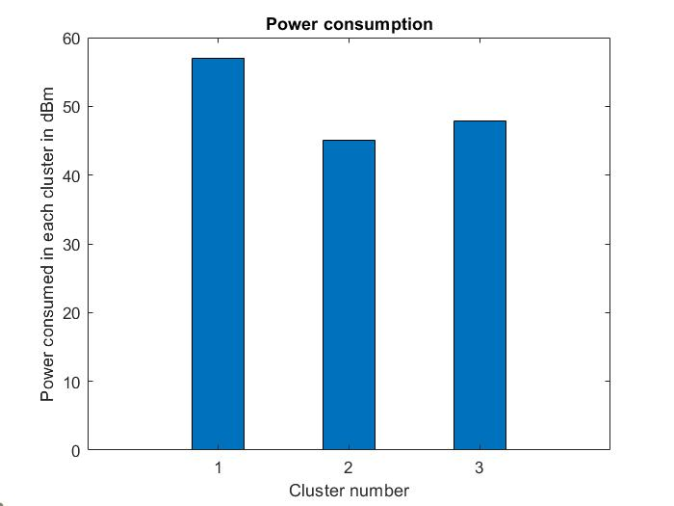

Figure 6.7 Power Consumption at time t2 for 100 UEs

From Figure 6.8, it is observed that QoS values are close to 1 in each cluster, at time instance t2. Thus, it can be inferred that all the UEs receive a good quality 5G connection. Hence, applications like streaming, video calls and gaming experiences will match the satisfactory levels.

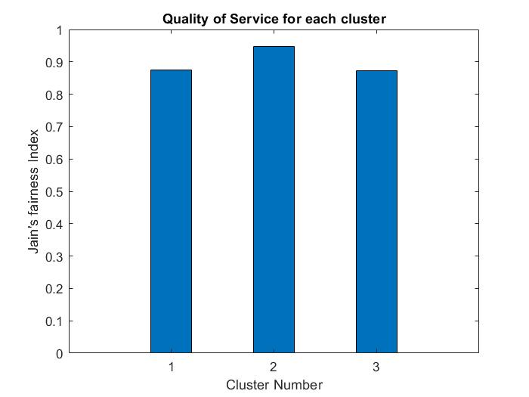

Figure 6.8 Quality of Service at time t2 for 100 UEs

The average sum rate for each cluster is computed using the Shannon-Hartley theorem for an UE VBS selected by the proposed algorithm against an UE VBS selected at random (and for an LTE base station) at time instance t2, as shown in the Figure 6.9.

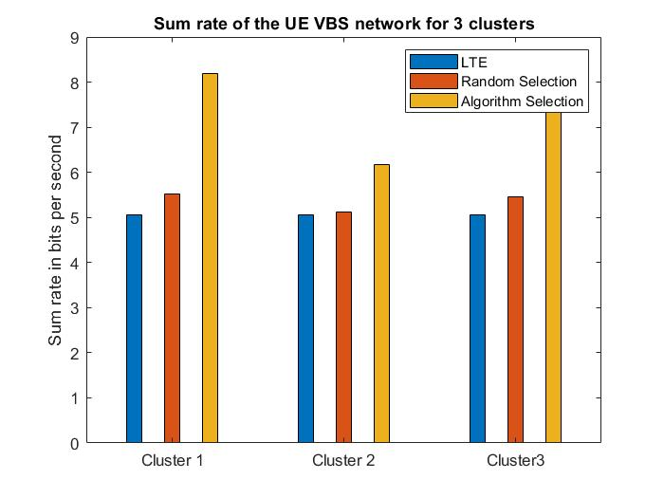

Figure 6.9 Average Sum rate for different clusters at time t2 for 100 UEs

From each cluster, the algorithm selects an UE to act as a VBS using power received, battery discharge rate and SINR, at time instance t3 as shown in the Figure 6.10.

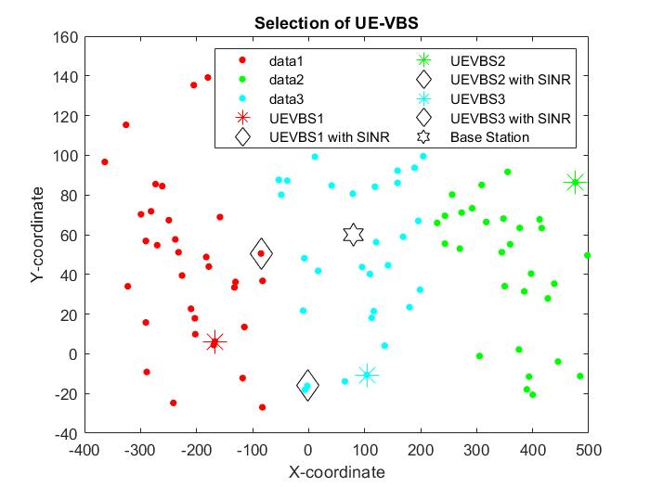

Figure 6.10 Selection of UE VBS for 100 UEs, at time t3

The power consumption in each cluster is computed using the difference between transmitted and received powers between the UEs, Base Station and UE-VBS, selected at using the algorithm, at time instance t3, as shown in the Figure 6.11.

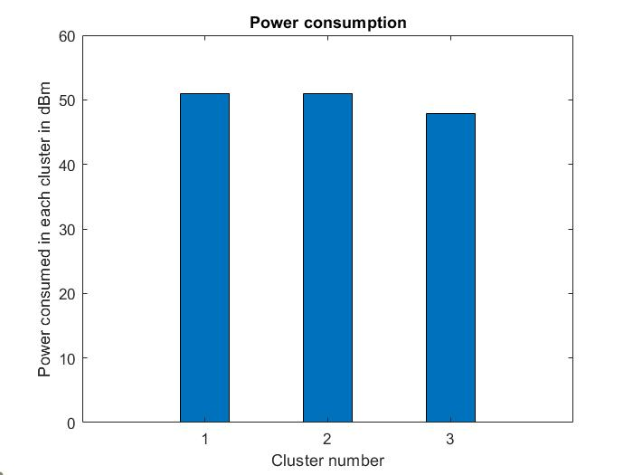

Figure 6.11 Power Consumption at time t3 for 100 UEs

From Figure 6.12, it is observed that QoS values are close to 1 in each cluster, at time instance t3. Thus, it can be inferred that all the UEs receive a good quality 5G connection. Hence, applications like streaming, video calls and gaming experiences will match the satisfactory levels.

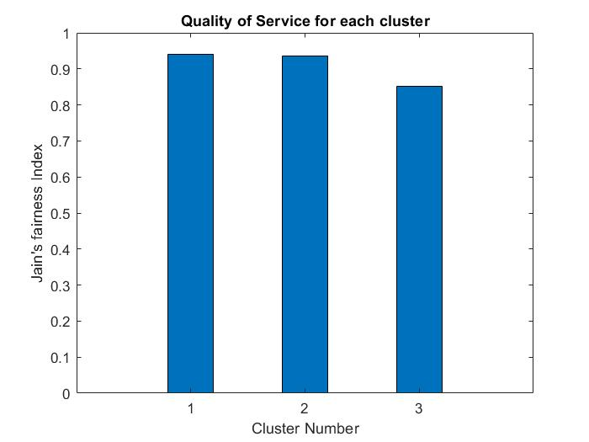

Figure 6.12 Quality of Service at time t3 for 100 UEs

The average sum rate for each cluster is computed using the Shannon-Hartley theorem for an UE VBS selected by the proposed algorithm against an UE VBS selected at random (and for an LTE base station) at time instance t3, as shown in the Figure 6.13.

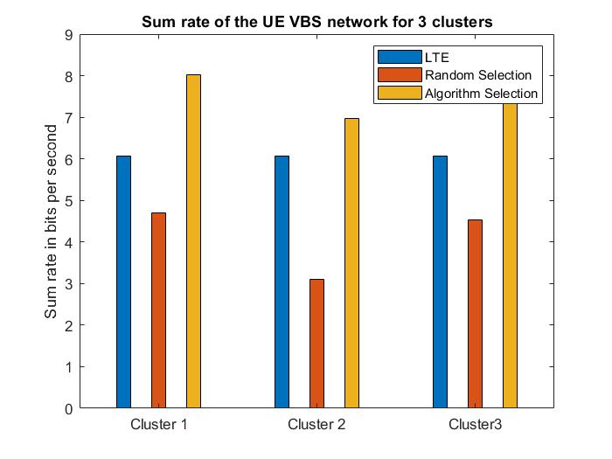

Figure 6.13 Average Sum rate for different clusters at time t3 for 100 UEs

**6.2 PERFORMANCE ANALYSIS FOR VARIOUS CLUSTER SIZES**

From each cluster, the algorithm selects an UE to act as a VBS using power received, battery discharge rate and SINR, for cluster size 2 as shown in the Figure 6.14.

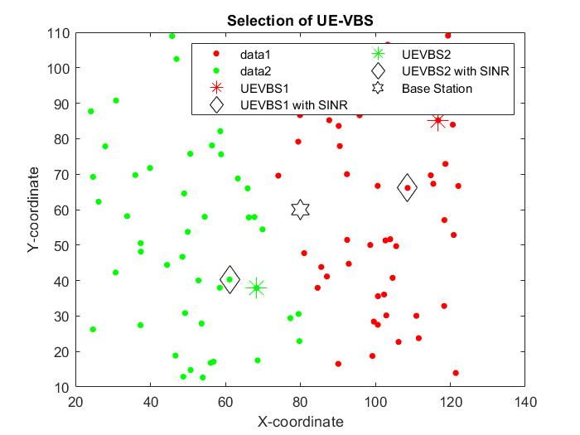

Figure 6.14 Selection of UE VBS for cluster size 2

The power consumption in each cluster is computed using the difference between transmitted and received powers between the UEs, Base Station and UE-VBS, selected at using the algorithm for cluster size 2, as shown in the Figure 6.15.

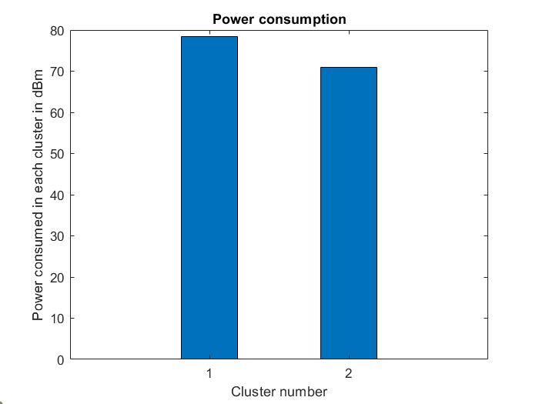

Figure 6.15 Power Consumption of UE VBS for cluster size 2

From Figure 6.16, it is observed that QoS values are close to 1 in each cluster, for cluster size 2. Thus, it can be inferred that all the UEs receive a good quality 5G connection. Hence, applications like streaming, video calls and gaming experiences will match the satisfactory levels.

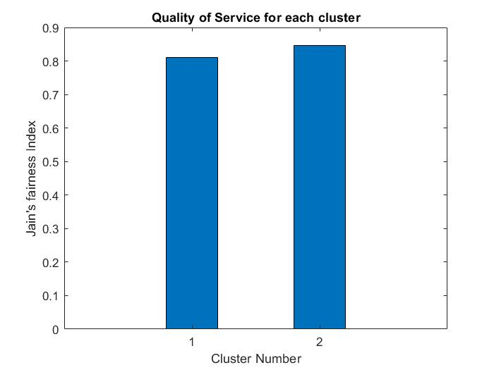

Figure 6.16 Quality of Service for cluster size 2

The average sum rate for each cluster is computed using the Shannon-Hartley theorem for an UE VBS selected by the proposed algorithm against an UE VBS selected at random (and for an LTE base station) for cluster size 2 as shown in the Figure 6.17.

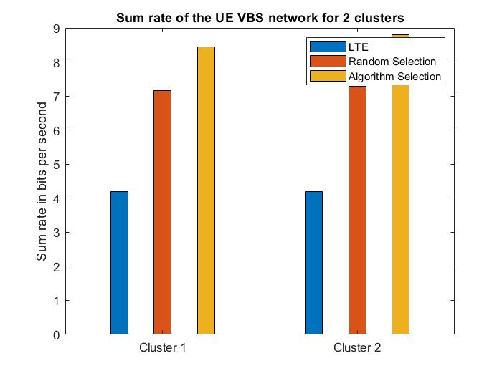

Figure 6.17 Average sum rate of UE VBS for cluster size 2

From each cluster, the algorithm selects an UE to act as a VBS using power received, battery discharge rate and SINR, for cluster size 3 as shown in the Figure 6.18.

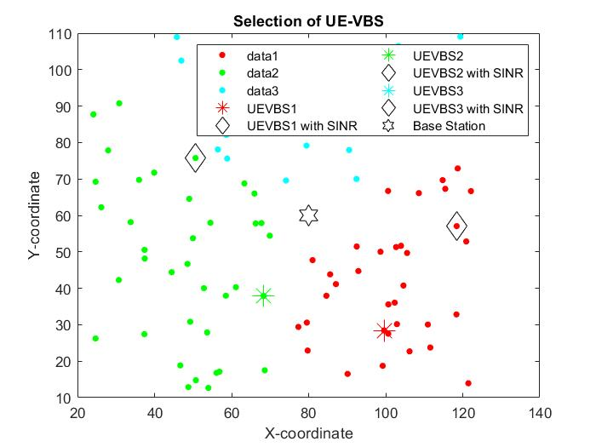

Figure 6.18 Selection of UE VBS for cluster size 3

The power consumption in each cluster is computed using the difference between transmitted and received powers between the UEs, Base Station and UE-VBS, selected at using the algorithm for cluster size 3, as shown in the Figure 6.19.

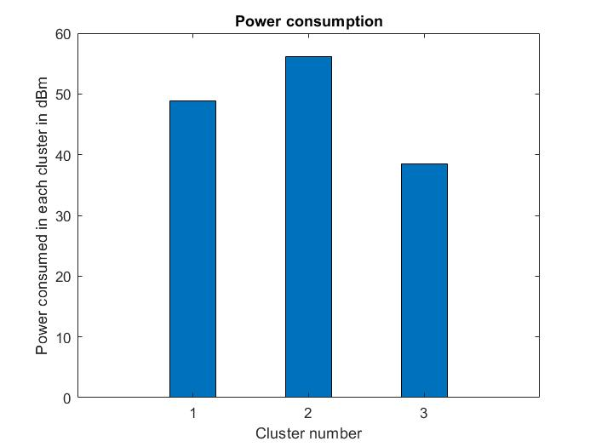

Figure 6.19 Power Consumption of UE VBS for cluster size 3

From Figure 6.20, it is observed that QoS values are close to 1 in each cluster , for cluster size 3. Thus, it can be inferred that all the UEs receive a good quality 5G connection. Hence, applications like streaming, video calls and gaming experiences will match the satisfactory levels.

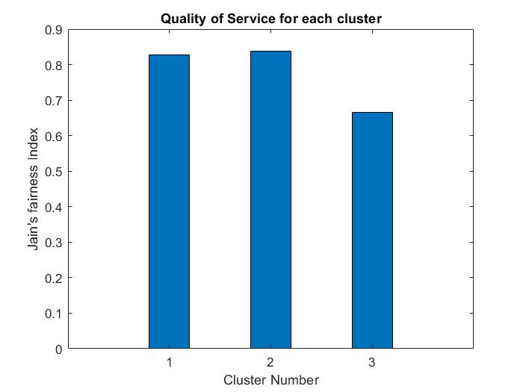

Figure 6.20 Quality of Service for cluster size 3

The average sum rate for each cluster is computed using the Shannon-Hartley theorem for an UE VBS selected by the proposed algorithm against an UE VBS selected at random (and for an LTE base station) for cluster size 3 as shown in the Figure 6.21.

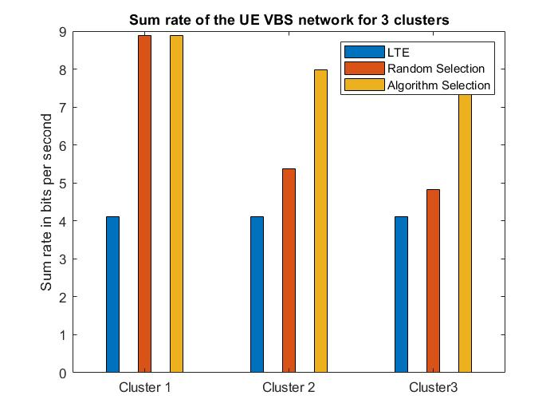

Figure 6.21 Average sum rate of UE VBS for cluster size 3

From each cluster, the algorithm selects an UE to act as a VBS using power received, battery discharge rate and SINR, for cluster size 4 as shown in the Figure 6.22.

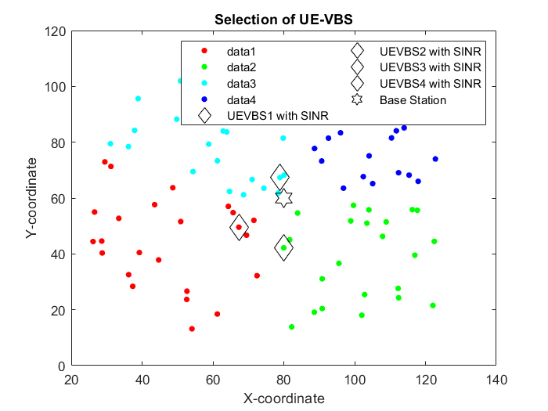

Figure 6.22 Selection of UE VBS for cluster size 4

The power consumption in each cluster is computed using the difference between transmitted and received powers between the UEs, Base Station and UE-VBS, selected at using the algorithm for cluster size 4, as shown in the Figure 6.23.

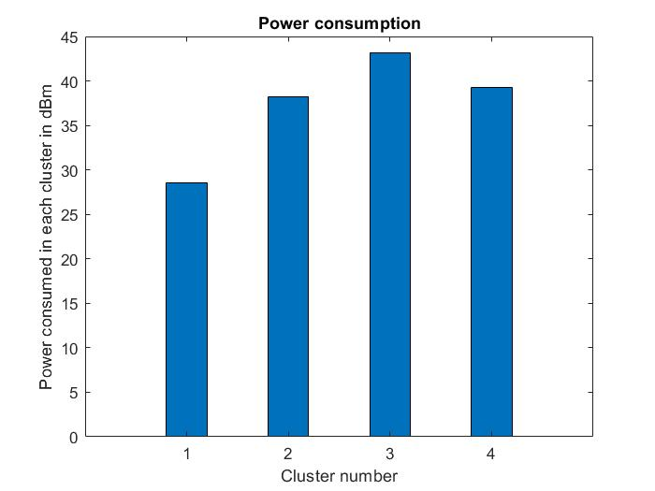

Figure 6.23 Power Consumption of UE VBS for cluster size 4

From Figure 6.24, it is observed that QoS values are close to 1 in each cluster, for cluster size 4. Thus, it can be inferred that all the UEs receive a good quality 5G connection. Hence, applications like streaming, video calls and gaming experiences will match the satisfactory levels.

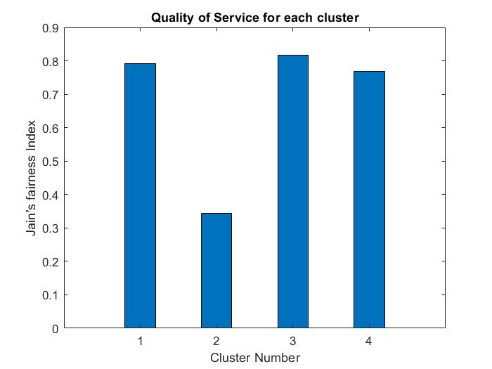

Figure 6.24 Quality of Service for cluster size 4

The average sum rate for each cluster is computed using the Shannon-Hartley theorem for an UE VBS selected by the proposed algorithm against an UE VBS selected at random (and for an LTE base station) for cluster size 4 as shown in the Figure 6.25.

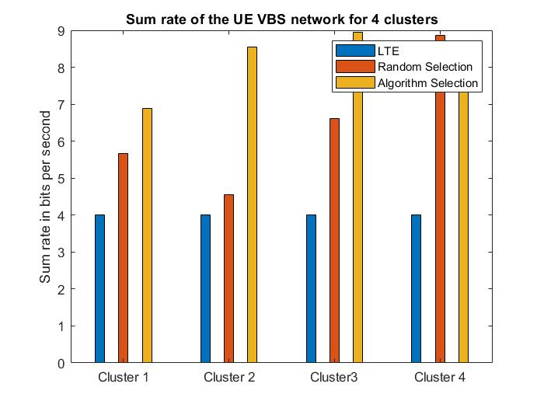

Figure 6.25 Average sum rate of UE VBS for cluster size 4

From each cluster, the algorithm selects an UE to act as a VBS using power received, battery discharge rate and SINR, for cluster size 5 as shown in the Figure 6.26.

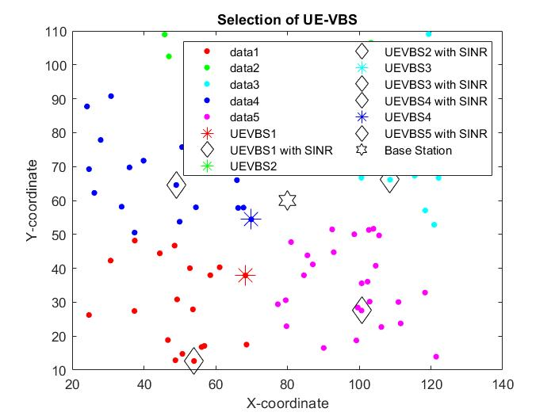

Figure 6.26 Selection of UE VBS for cluster size 5

The power consumption in each cluster is computed using the difference between transmitted and received powers between the UEs, Base Station and UE-VBS, selected at using the algorithm for cluster size 5, as shown in the Figure 6.27.

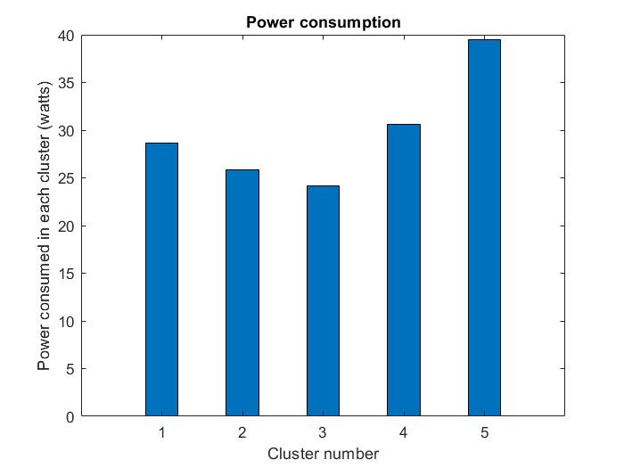

Figure 6.27 Power Consumption of UE VBS for cluster size 5

From Figure 6.28, it is observed that QoS values are close to 1 in each cluster , for cluster size 5. Thus, it can be inferred that all the UEs receive a good quality 5G connection. Hence, applications like streaming, video calls and gaming experiences will match the satisfactory levels.

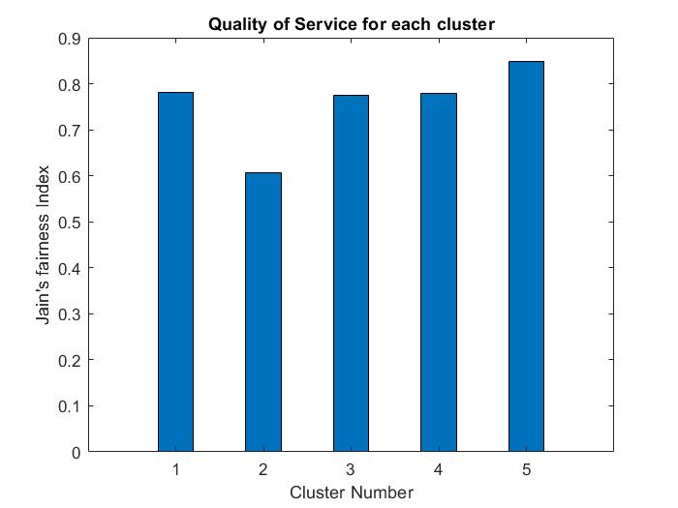

Figure 6.28 Quality of Service for cluster size 5

The average sum rate for each cluster is computed using the Shannon-Hartley theorem for an UE VBS selected by the proposed algorithm against an UE VBS selected at random (and for an LTE base station) for cluster size 5 as shown in the Figure 6.29.

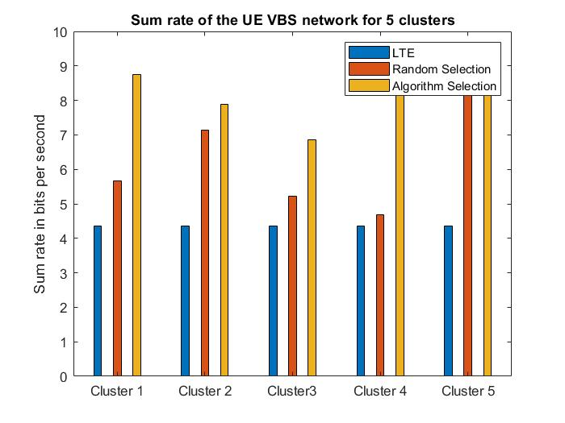

Figure 6.29 Average sum rate of UE VBS for cluster size 5

From each cluster, the algorithm selects an UE to act as a VBS using power received, battery discharge rate and SINR, for cluster size 6 as shown in the Figure 6.30.

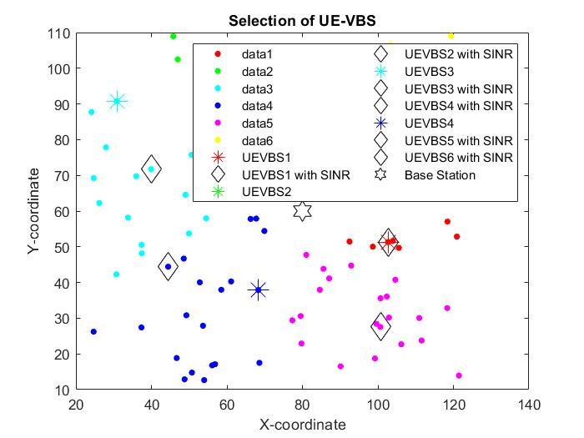

Figure 6.30 Selection of UE VBS for cluster size 6

The power consumption in each cluster is computed using the difference between transmitted and received powers between the UEs, Base Station and UE-VBS, selected at using the algorithm for cluster size 6, as shown in the Figure 6.31.

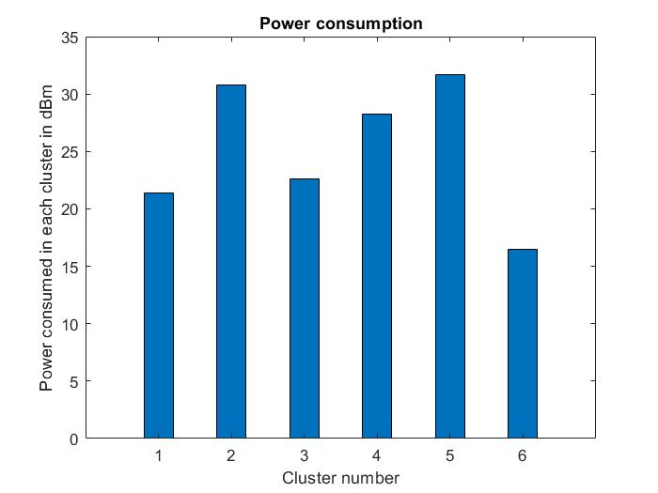

Figure 6.31 Power Consumption of UE VBS for cluster size 6

From Figure 6.32, it is observed that QoS values are close to 1 in each cluster, for cluster size 6. Thus, it can be inferred that all the UEs receive a good quality 5G connection. Hence, applications like streaming, video calls and gaming experiences will match the satisfactory levels.

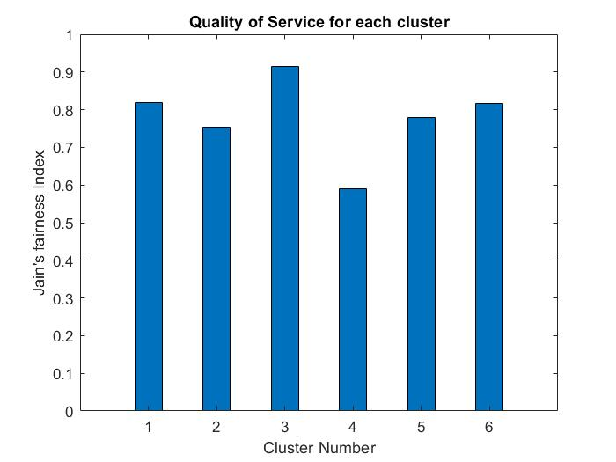

Figure 6.32 Quality of Service for cluster size 6

The average sum rate for each cluster is computed using the Shannon-Hartley theorem for an UE VBS selected by the proposed algorithm against an UE VBS selected at random (and for an LTE base station) for cluster size 6 as shown in the Figure 6.33.

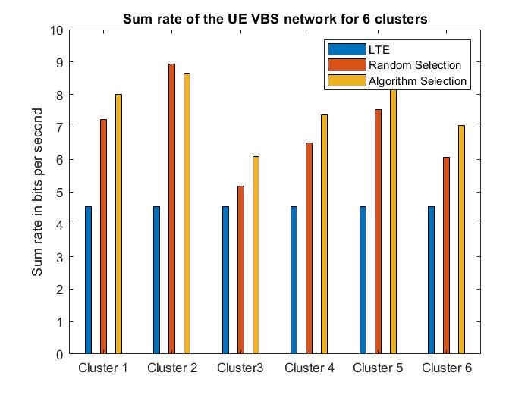

Figure 6.33 Average sum rate of UE VBS for cluster size 6

From each cluster, the algorithm selects an UE to act as a VBS using power received, battery discharge rate and SINR, for cluster size 7 as shown in the Figure 6.34.

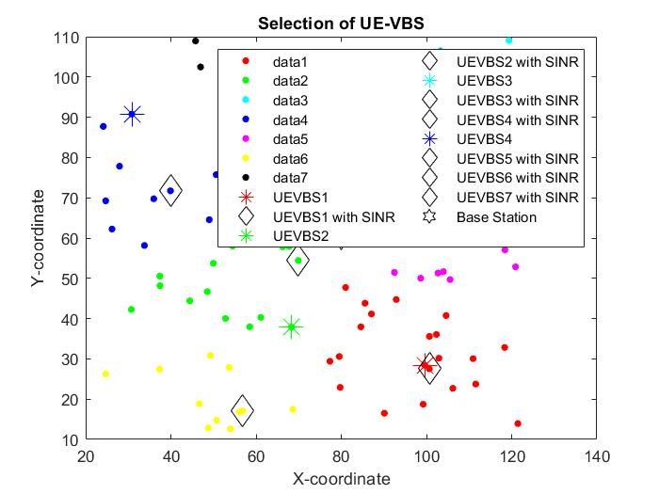

Figure 6.34 Selection of UE VBS for cluster size 7

The power consumption in each cluster is computed using the difference between transmitted and received powers between the UEs, Base Station and UE-VBS, selected at using the algorithm for cluster size 7, as shown in the Figure 6.35.

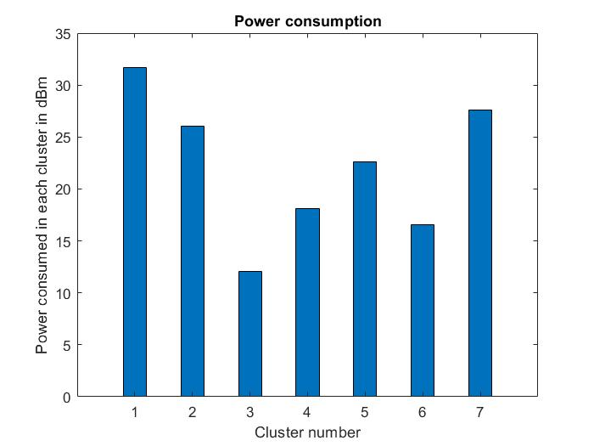

Figure 6.35 Power Consumption of UE VBS for cluster size 7

From Figure 6.36, it is observed that QoS values are close to 1 in each cluster, for cluster size 7. Thus, it can be inferred that all the UEs receive a good quality 5G connection. Hence, applications like streaming, video calls and gaming experiences will match the satisfactory levels.

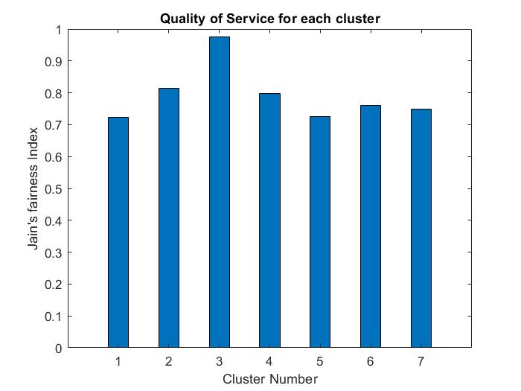

Figure 6.36 Quality of Service for cluster size 7

The average sum rate for each cluster is computed using the Shannon-Hartley theorem for an UE VBS selected by the proposed algorithm against an UE VBS selected at random (and for an LTE base station) for cluster size 7 as shown in the Figure 6.37.

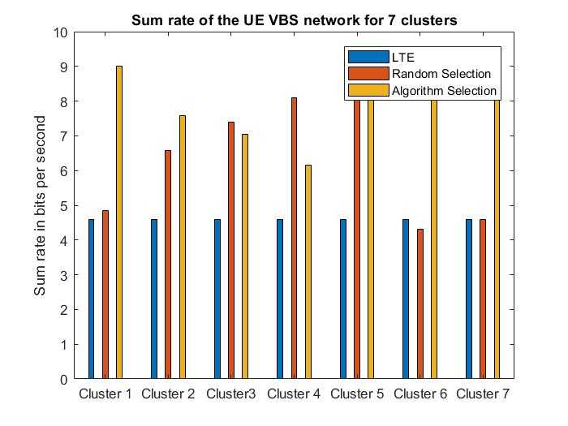

Figure 6.37 Average sum rate of UE VBS for cluster size 7

From each cluster, the algorithm selects an UE to act as a VBS using power received, battery discharge rate and SINR, for cluster size 8 as shown in the Figure 6.38.

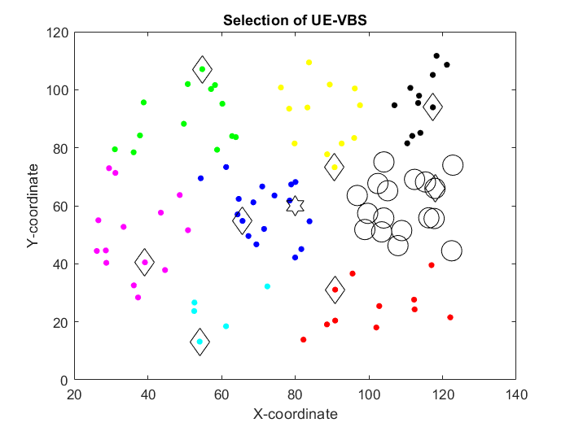

Figure 6.38 Selection of UE VBS for cluster size 8

The power consumption in each cluster is computed using the difference between transmitted and received powers between the UEs, Base Station and UE-VBS, selected at using the algorithm for cluster size 8, as shown in the Figure 6.39.

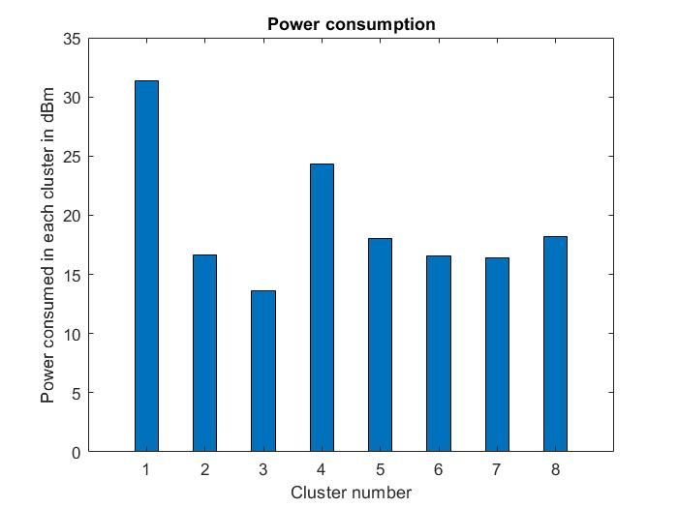

Figure 6.39 Power Consumption of UE VBS for cluster size 8

From Figure 6.40, it is observed that QoS values are close to 1 in each cluster , for cluster size 8. Thus, it can be inferred that all the UEs receive a good quality 5G connection. Hence, applications like streaming, video calls and gaming experiences will match the satisfactory levels.

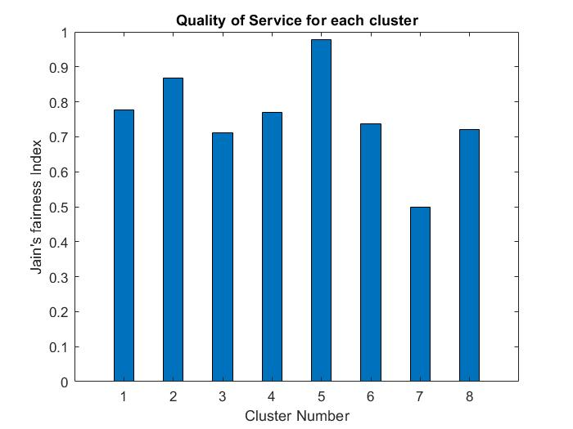

Figure 6.40 Quality of Service for cluster size 8

The average sum rate for each cluster is computed using the Shannon-Hartley theorem for an UE VBS selected by the proposed algorithm against an UE VBS selected at random (and for an LTE base station) for cluster size 8 as shown in the Figure 6.41.

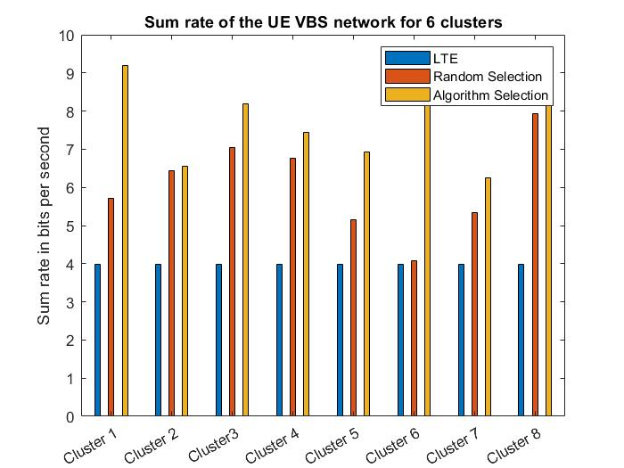

Figure 6.41 Average sum rate of UE VBS for cluster size 8

**6.3 SYSTEM PERFORMANCE INFERENCE**

The average sum rate for the system with different cluster sizes is plotted in the Figure 6.42. Performance of the system with cluster size 2 is neglected since it might lead to underfitting. Since the availability of UE VBS in each cluster is dynamic, the cluster size can be chosen to fit the necessary requirements, ideally 4, 5 or 8 in this case.

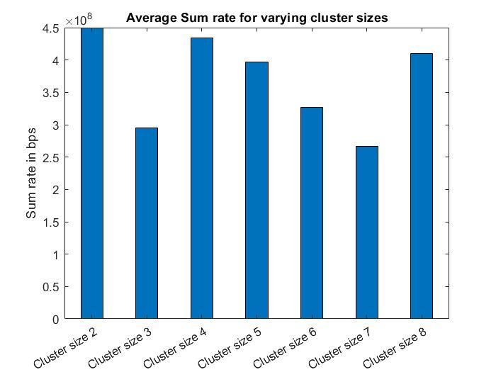

Figure 6.42 Average sum rate for varying clusters

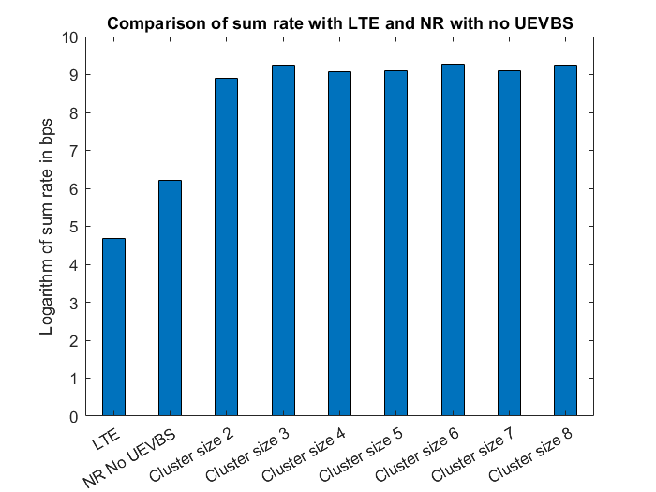

Figure 6.43 Comparison of average sum rate with LTE and NR with no UEVBS

The average sum rate of an LTE system and that of a 5G system with no UE VBS is plotted along with the average sum rate of various 5G UE VBS systems with varying cluster sizes, in the Figure 6.43. It can be inferred that the usage of 5G UE VBSs shows a significantly better system performance than the other mentioned systems.

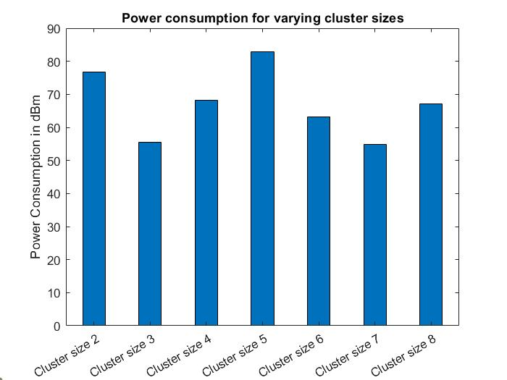

Figure 6.44 Comparison of average power consumption for different cluster sizes

From fig 6.44, it can be inferred that cluster size 5 has the highest cumulative power consumption compared to the other cluster sizes. Hence, it would not be a suitable choice for cluster size. The power consumption across the various sizes varies due to the geographical distribution of the UEs in each cluster. This parameter, along with Quality of Service and Sum Rate, can be effectively used to determine the number of clusters which can operate, at the most ideal behaviour, for a 5G UE-VBS network.